List of currently impounded horses
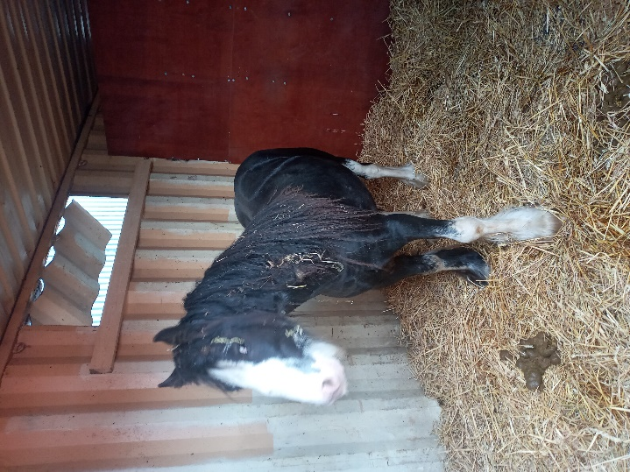
Date seized | Date seized | Date seized | Date seized
Area seized from | Area seized from | Area seized from | Area seized from
Description | Description | Description | Description
Disposal date | Disposal date | Disposal date | Disposal date

